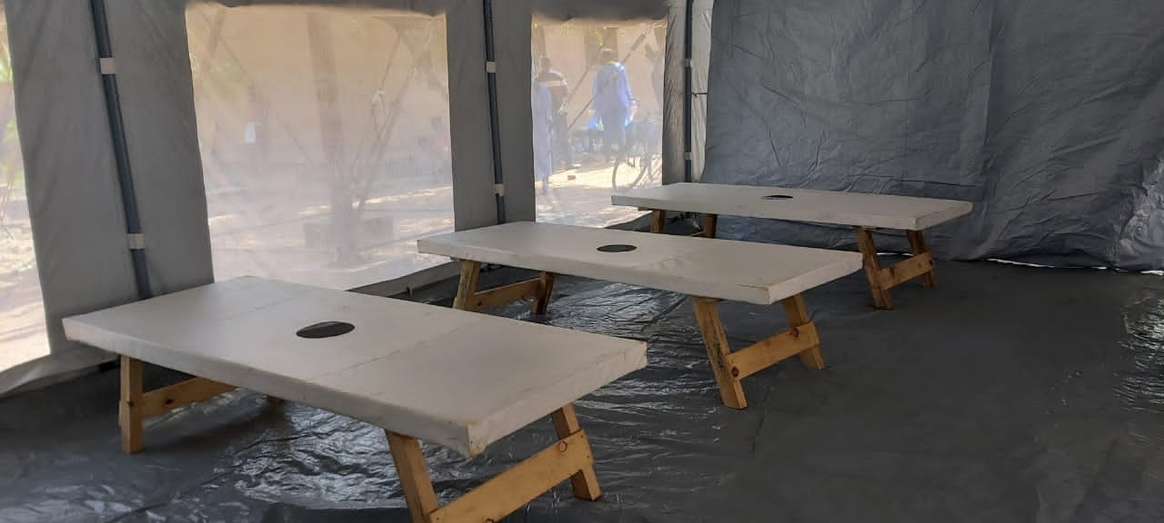
Ulongwe CTC
SITUATION  REPORT  EHU EMT CHOLERA  Malawi |  | 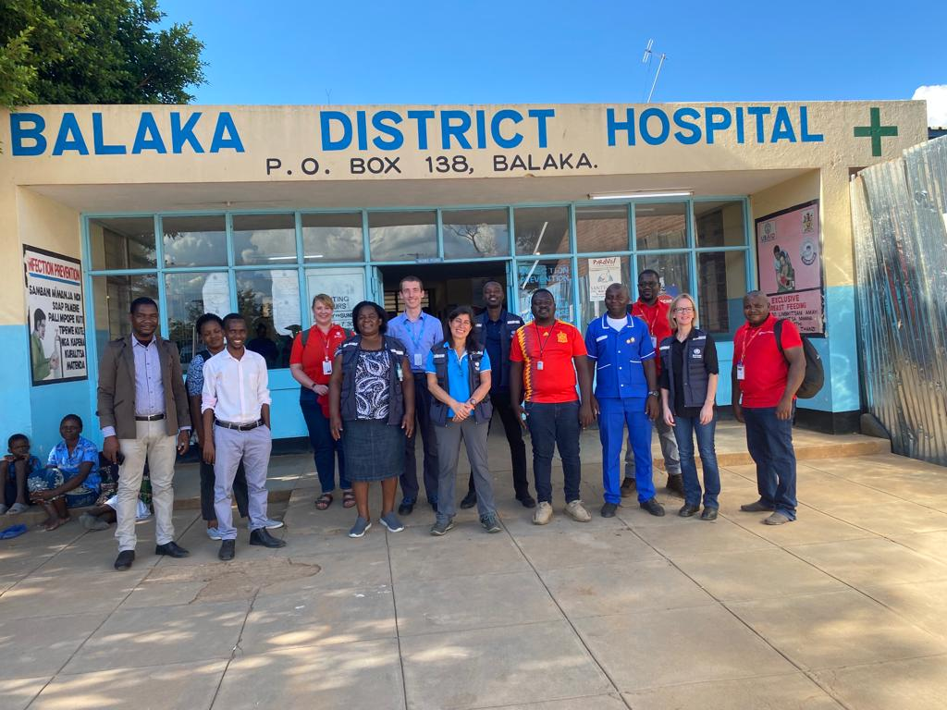
Week Two 13/02/23 |  | Prepared by the EHU and Country Office Malawi  Situation Overview  Weekly Highlights  - Biweekly coordination meeting with WHO started  - The Nurses finalized registiration and following up for the doctors.  - Meet with the community in Ulongwe  - Follow up on the delayed paperwork foe EHU supply shipment from both Dubai and the Netherlands  - Clinical Lead and entire clinical team, including 7 roster clinicians, arrived in country this week and induction for roster staff was completed.  - Staff shifts at the CTC’s began Sat, Feb 11. Initial focus is improving IPC throughout CTC’s as well as screening & triage and patient/guardian flow (in collaboration with WASH team). At the same time, clinical team is working with national staff to improve patient monitoring, case management, and standardizing patient records. We have also begun training on data collection with the new Patient Admission and Case Management forms, created and approved by WHO and Malawi MoH last week.  - Most of the existing training resources and materials have been adapted to current cholera context, a couple of topics remain to be modified  - Implement MUAC screening at screening and triage for children <5 and pregnant and breastfeeding women  - Ulongwe new CTC infrastructure is complete for a 35-bed capacity, with improved patient/healthcare worker flow.  - Plumbing work on in both location to increase water points in for improved access.  - Setting up of improved decontamination areas, entry and exit points  - Support set ups of CTCs and finalizing the set ups in Ulongwe  - MEAL officer has been identified through the Balaka CO and has begun training on data collection and IMPACT with the MEAL manager and Clinical Lead. Rapid assessment done by EHU and CO in Balaka
TERMS OF REFERENCE
EMT Specialised Care Team, medicines, and medical equipment for Cholera, to be deployed to either Lilongwe or Blantyre to support an existing Cholera Treatment Centre (CTCs) for six weeks.
.
Areas of Immediate Concerns/Action
- Dely in supplies and set up of CTC
- Medicine shortage at all levels of the health structure, predominately premade ORS and ringer lactate
- Potential overuse of IV medication leading to stock outs, due to staff shortage and guardians not trained on how to support
- Staff rotating daily between their current clinical role and supporting the CTC. High risk of cross infection
- Communities crossing the CTC boundary to bring food to patients
- Confusion between guardian and visitors to patient. No identified invidual guardian per patient their care role
- No formal referral pathways
- Huge IPC concerns including, no clear flow, handwashing and sanitation

Internal Communication
Constraints
- Delay in stock arriving, limits access to CTCs as team are constrained by lack of PPE access. Delay is due to lead times with supplier
- No access to Line List from Balaka despite continued requests to WHO and DHO
- Continue changes to operational plan due to situation changing and WHO assessment not having been conducted prior to ToR
- Currently full deployment is not funded
- Constant changing of request and need leading to delay in deploying clinical staff as need unknown until this weekend
- CTC hardware (WASH and IPC) supply chain is still poor given the logistic and financial challenges, as much as WHO is supporting, hence the drag to open the new CTC
Next Steps

Operations
- Engaging with DHO and agreed on modus operandi
- Follow up with EMT team leader the regidtiration process of doctors
- Follow up of supplies from WHO and EHU supply shipment clearance
- Analyzing budget gaps, available options and agree on way forward
- Follow up local procurments
- Continue to attend national and district meetings
- Ensure all WHO/MoH documentation is now with the team

WASH
- In regards to joint assessment with WHO logs and MOH, a consesus was reached to organise new CTC s in Balaka and Ulongwe given the glaring IPC challenges of the existing infrastructures provided for a CTC

Ulongwe CTC
- Ulongwe new CTC infrastructure is complete for a 35-bed capacity, with improved patient/healthcare worker flow.
- FEB 13th , The clinical team was taken through the CTC set up for further review on IPC safety, Patient/health staff flow and case managemet section of the proposed case plans
- Guardian sanitation facilities in Ulongwe is completed, however, requires improved hand washing stations,
- Patient sanitation is complete
The current activitites involved organizing the laundry areas in red and green zones
- Plumbing work on in both location to increase water points in for improved access.
- Setting up of improved decontamination areas, entry and exit points

Balaka CTC
- The hospitalization tents are installed, awaiting floor repairs and plastic sheets, further improvement are required on the tent for patient safety
- The existing abandoned morgue has been cleaned and the doors fixed
- The protective fence around the CTC is complete, and patient/health care workers flow plan completed
The current ongoing activities include,
- The triage installation
- The CTC drainage
- The recovery area construction
- Plumbing works for water supply
- Sanitation facilities improvement.
- Site planning of decontamination areas(handwashing, footbath/spray station), as well as chlorine preparation areas
Given the above activities, the new CTC site is not yet ready for occupation as highlighted in constraint section above

Clinical
- Assessments of both Balaka and Ulongwe CTC’s have been completed
- Clinical Lead and entire clinical team, including 7 roster clinicians, arrived in country this week and induction for roster staff was completed.
- Staff shifts at the CTC’s began Sat, Feb 11. Initial focus is improving IPC throughout CTC’s as well as screening & triage and patient/guardian flow (in collaboration with WASH team). At the same time, clinical team is working with national staff to improve patient monitoring, case management, and standardizing patient records. We have also begun training on data collection with the new Patient Admission and Case Management forms, created and approved by WHO and Malawi MoH last week.
- Most of the existing training resources and materials have been adapted to current cholera context, a couple of topics remain to be modified
- Work with the clinical teams in the CTCs to identify gaps that require immediate intervention before transition to the new CTCs- this has been ongoing throughout the week and will continue until the anticipated moves to the new CTC layouts in the next week or two.
- MEAL officer has been identified through the Balaka CO and has begun training on data collection and IMPACT with the MEAL manager and Clinical Lead.
- Successful coordination meeting with WHO Health Emergencies Team based in Balaka to collaborate on mapping of needs and activities, incoming surge staff planning, supply management and distribution and referral pathways.

Challenges- Doctors have yet to be registered with Malawi Medical Council due to delays in authorization of documents from their home country. This is anticipated to be resolved by early to mid-week.

Anticipated next week- Continue all of the above with 24/7 CTC shift coverage and begin to integrate more training, mentorship and direct patient care, with a focus on IPC and Case Management, in preparation to transition patients over to the new CTC layouts.

Nutrition
- Develop plan with district for those patients not receiving food- WFP will begin attending weekly national Case Management meeting
- Implement MUAC screening at screening and triage for children <5 and pregnant and breastfeeding women
- Advanced training for cholera treatment in children with SAM planned in both CTC’s, as well as IYCF-E during cholera (on the job and with PPT slides).

Supply Chain
Confirm date for importatation of goods
- Liaise with CO for staff arriving and transportation to Balaka
- Second vehicle

HR

- All nurses have finalized registiration and following up doctors registiration
- Rota for doctors and nurses for the first 2 weeks was prepared

Currently Deployed staff
Name | Role | Arrival Date | Planned Departure Date | Remark
Kate Jarman | OPS lead | 29 Jan 2023 | 10 Feb 2023 | Left the country
Kassahun Tamirat | EHU OPS lead | 08th Feb. 2023 | TBC
Megan McMillin | EHU Clinical Lead | 6th Feb, 2023 | 19 March, 2023 | May be possible to extend as needed
Palal Areman | Supply Chain Manager | 29 Jan 2023 | TBC
Thomas Odari | WASH manager | 31 Jan 2023 | TBC
Sofia Rapti | Lead Doctor | 1 Feb 2023 | 7 March 2023
Josephine Kimathi | Lead Nurse | 3 Feb 20 23 | TBC
Daniel Tabaro | Doctor | 9 Feb 2023 | TBC
Didier Mwesha | Roster Doctor | 9 Feb 2023 | TBC
Leon Mbaabu | Roster Doctor | 8 Feb 2023 | TBC
Milka Nyamache | Roster Nurse | 8 Feb 2023 | TBC
Doreen Ambayo | Roster Nurse | 8 Feb 2023 | TBC
Isojick Loveness | Roster Nurse | 8 Feb 2023 | TBC
Laban Mwirigi | Roster Nurse | 8 Feb 2023 | TBC
Ruth Marimbet | Roster Nurse | 8 Feb 2023 | TBC

Clinical
Clinical staff is in country and complete. A MEAL officer has been recruited from the CO and line managed by Clinical Lead Megan, backstopped by EHU Meal Manager Nora Bambrick.

Clinical Lead is also line managing Lead Doctor Sofia Rapti and Lead Nurse Josephine Kimathi, who in turn are line managing the other core and roster doctors and nurses: Dr. Daniel Tabaro, Dr. Didier Mwesha, Dr. Leon Mbaabu, Milka Nyamache, Doreen Ambayo, Isojick Loveness, Laban Mwirigi and Ruth Marimbet.

EHU Core Team Organogram

